**Assignment Part-1**

We used MLP to classify ciphar-10 dataset. Each record of size 3072 and the output has 10 classes. Using the MNIST example code I build a MLP with one input, one hidden layer of size 512 neurons in it. The activation function in hidden layers is “RELU”. The output layer activation function is “SOFTMAX”. The results are given below.

Test loss: 1.4060170072555542

Test accuracy: 0.5006

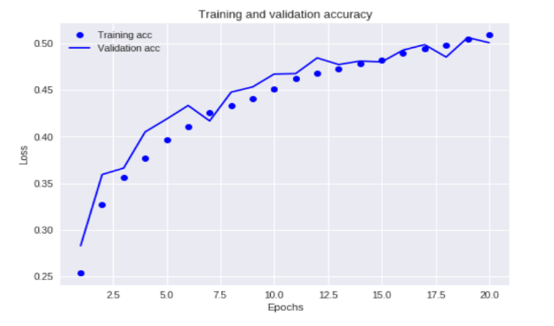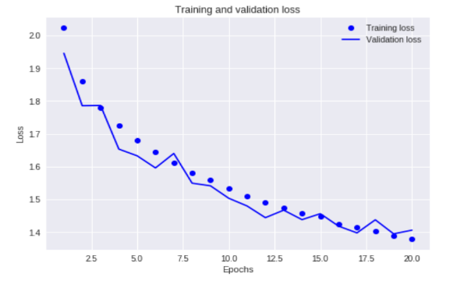

The above plots shows the Loss and Accuracy plots of both training and validation data.

So now let’s tune some of the hyper parameter and see the final results whether this is any change in accuracy and loss function.

**No of Epochs**

I tested with different number of epochs and finally figured out that 40 epochs gives very good result but over fitting a lot.

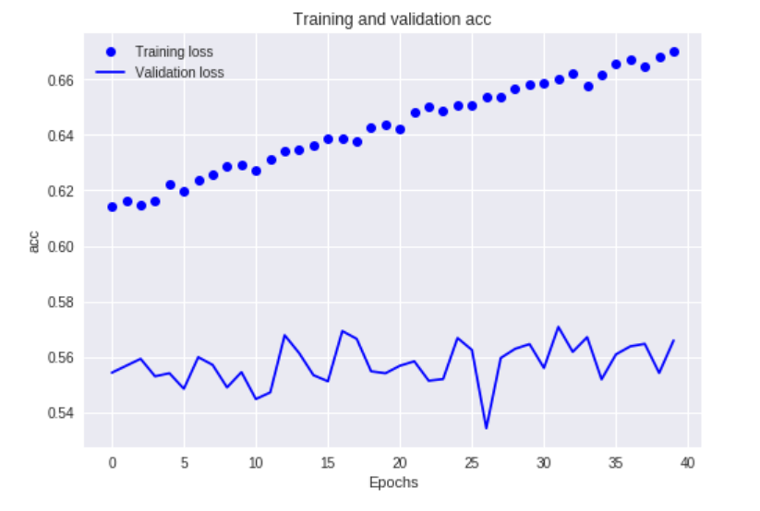

Likewise I did some modification in the hyper parameters and noted the losses and accuracy to each parameter and decided to take the parameters below to build a model.

**BEST MODEL**

**#Number of Epochs =40.**

**#Batch size as an input =256.**

**#Neuron size in each layer =512 in 1st layer and 256 in 2nd layer.**

**#we use Single hidden layer.**

**#Learning rate =0.001**

**#Activation function = Relu and softmax in output layer.**

**#Drop out =0.1 but ideal to check dropout till 0.2**

The final model accuracy and loss are plotted and decided that the given model is the best model.

Test loss: 1.2959563707351685

Test accuracy: 0.5404

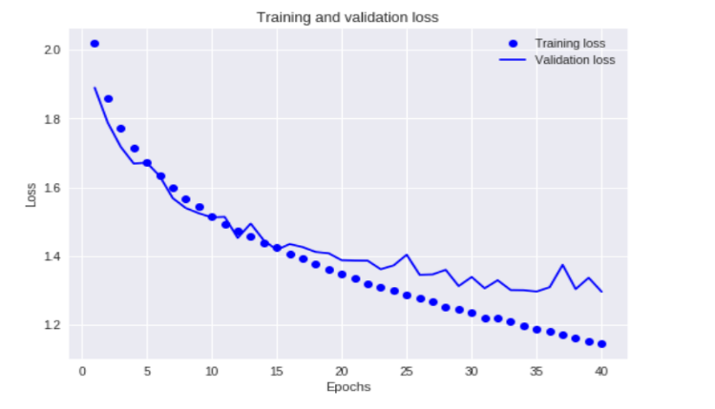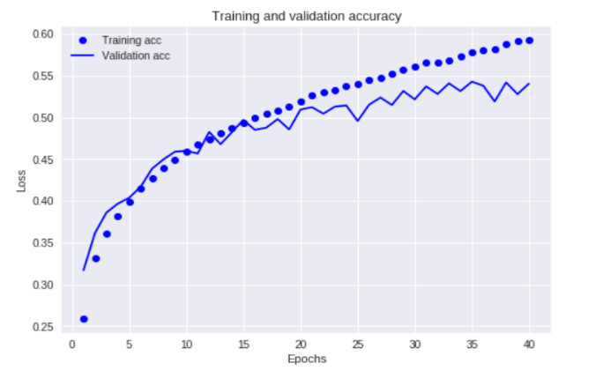

So even though my best model does over fit a bit but it is the best model so far which I plotted till now. So considered this a best model and It doesn’t mean that the other models are worthless. Still we changing the parameters will give some good results.